OREGON INSTITUTE OF TECHNOLOGY
Computer Systems Engineering Technology Department
CST 315 – Embedded Sensor Interfacing I/O
Lab 2 – Relaxation Oscillator and Capacitive Sensor
Name: Chris Thomas
PURPOSE:
The purpose of this lab is to investigate the behavior of a Capacitive Liquid Level Sensor.

EQUIPMENT AND SUPPLIES:
- Oscilloscope/DMM with probes
- Capacitive Sensor constructed in Lab1
- Power Supply and alligator clip cables
- Resistors: 1 – 3.3K, 1 – 1 Meg, 3 – 100 K
- 1 – LM393 Comparator
- Breadboard
- 2 plastic cups deep enough to contain capacitive sensor

PROCEDURES:
- Power up the scope and attach scope probes.
- Measure and record the value of the 1 Meg Ohm resistor (R1) with the DMM.
R1 = ________1.01M________
- Vcc will be +6V.
- Fill one of the plastic water cups with water.
- Measure and record the capacitance of the liquid level sensor while it is vertically positioned in the second plastic cup before water is poured into the cup. C = ___46pF_____
- Construct the circuit in Figure 1. Please note that pins 5, 6, and 7 are grounded, and that only one voltage from the power supply is needed (Vcc = 6V). IC1 is the LM393 Comparator Integrated Circuit.
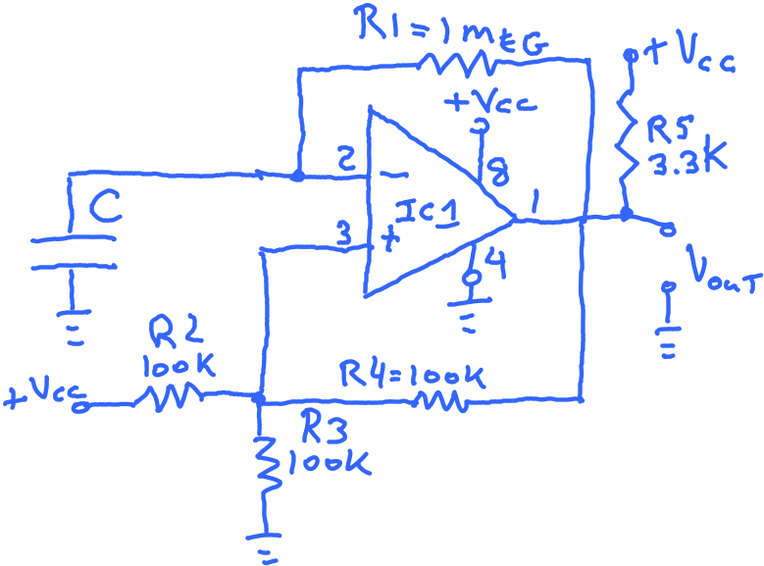
Figure 1
View of LM393 Looking Down on the Chip. Note the Notch at the Top of the Chip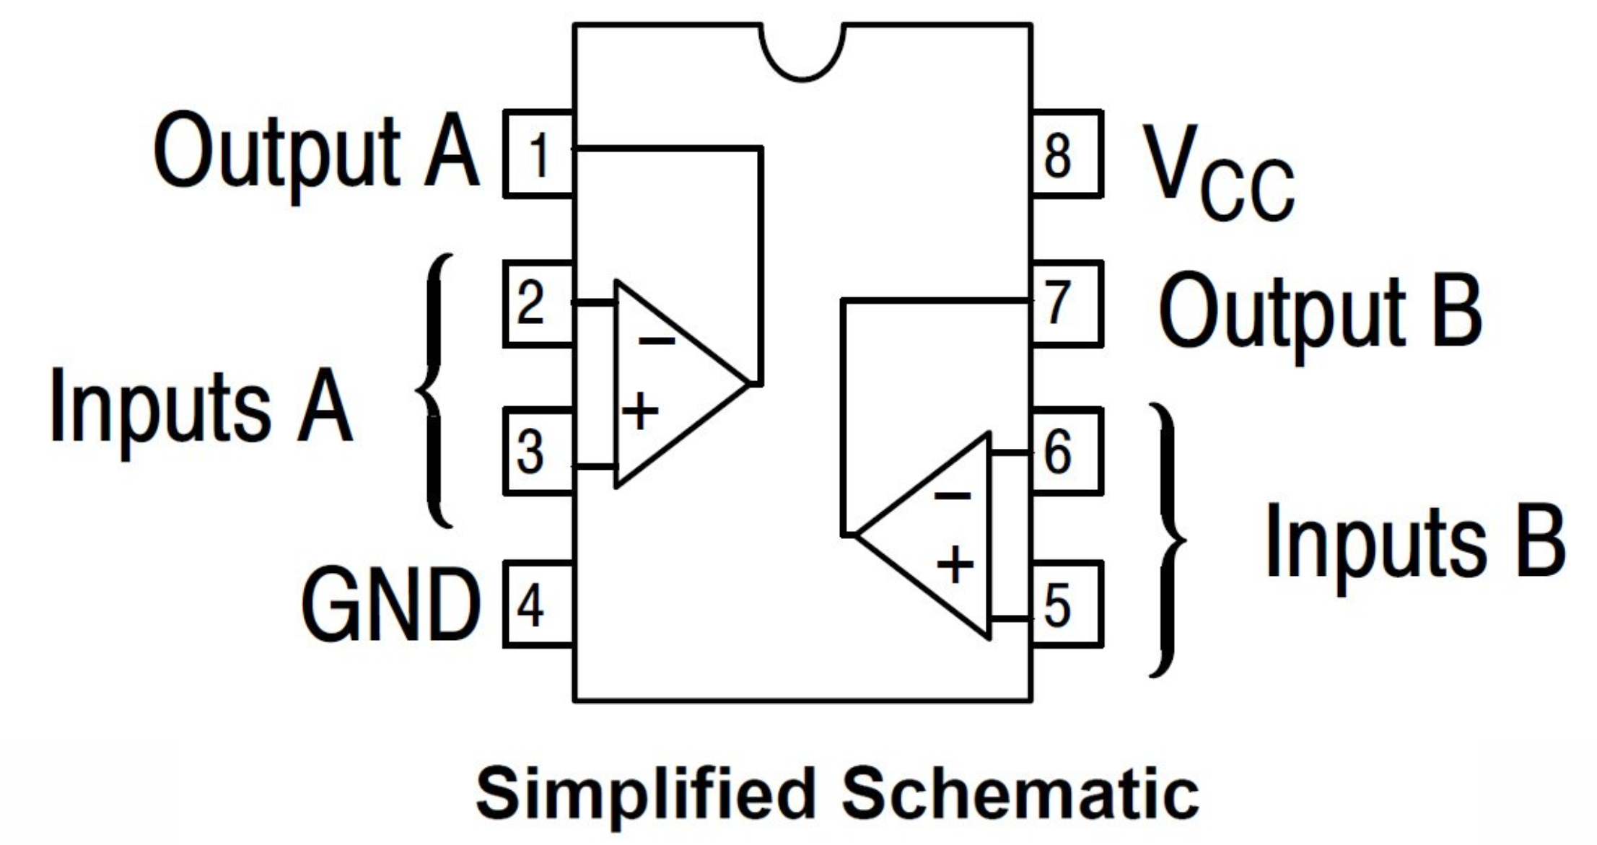
- Connect the liquid level sensor – C in Figure 1 - to the comparator circuit while the sensor is in the empty plastic cup. Turn on the power supply and measure and record the frequency of the output from the comparator circuit with the scope.
Frequency observed = _________________

- Using the techniques demonstrated by the instructor fill the cup containing the water level sensor with water to the 0, 1, 2, 3, and 4-inch levels of the sensor. Use the scope to measure the frequency produced by the relaxation oscillator at each water level. Record the results in the table below. Perform six runs so that the statistics will be valid. Be sure to remove water from between the plates of the sensor between runs by gently tapping the sensor on the bench top.

Water Level (inches) | 0” | 1” | 2” | 3” | 4”
Run 1 | 13.07 kHz | 6.11 kHz | 4.12 kHz | 3.22 kHz | 2.49 kHz
Run 2 | 11.03 kHz | 5.28 kHz | 3.86 kHz | 3.00 kHz | 2.51 kHz
Run 3 | 10.85 kHz | 4.89 kHz | 3.76 kHz | 3.02 kHz | 2.38 kHz
Run 4 | 10.41 kHz | 4.84 kHz | 3.65 kHz | 2.99 kHz | 2.46 kHz
Run 5 | 10.33 kHz | 4.86 kHz | 3.79 kHz | 2.95 kHz | 2.45 kHz
Run 6 | 10.17 kHz | 4.76 kHz | 3.60 kHz | 2.88 kHz | 2.36 kHz

- Put the data from the table above into an EXCEL Spreadsheet. Using the spreadsheet, calculate the average frequency value for each of the water levels - zero through four inches.

- Using water level values of 0, 1, 2, 3, and 4 inches of water make a plot in Excel of v Average Frequency versus Water Level

- Could the levels of other liquids be measured with this sensor? Explain why it would work or why it would not work.

  - Yes, you could use this with any other kind of liquid because the frequency would still change with more liquid in it.

- Send in this Word document filled in with the required information as well as a copy of your EXCEL Spreadsheet to Canvas.

- Save all information from this lab as you will need it for a later lab.

- Below is a graph of the capacitance of a water level sensor v water level. Note the linear relationship between the capacitance of the sensor and the water level. The value of R² calculated for the fit indicates how “good” the fit is – the closer to 1 the better.

Does your graph of Average Frequency versus Water Level have a linear relationship?
No it does not.

